

CYBER SECURITY

CS_TALAKUNCHI NETWORKS BATCH 2



NAME :- OJUS P. JAISWAL

**Internship Project 1**

**System Hacking**

**Task 1 :-** Hydra

Solution :-

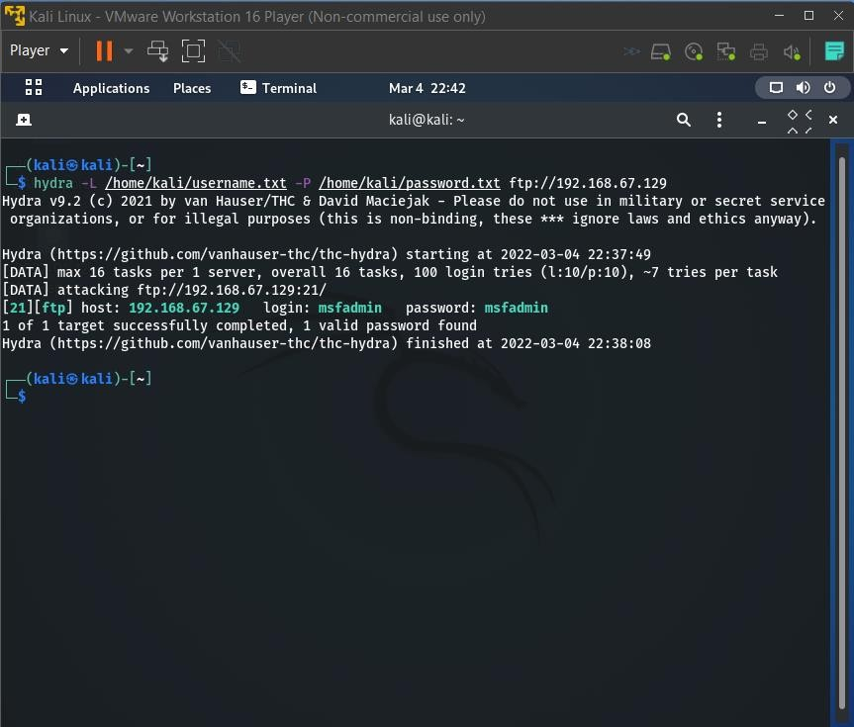

**Task 2 :-** Auxiliary Module

Solution :-

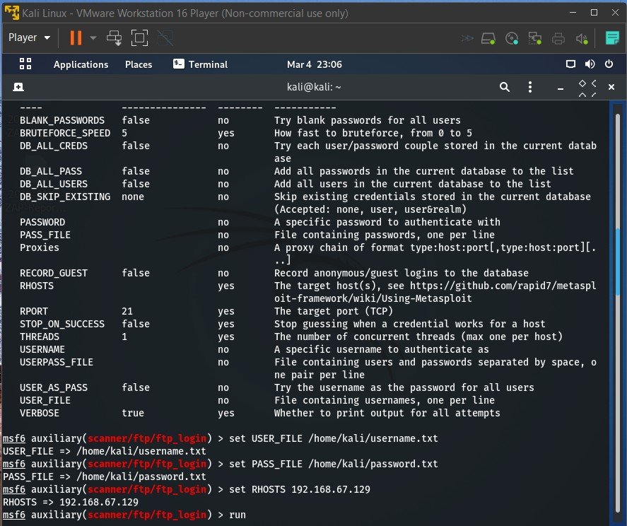

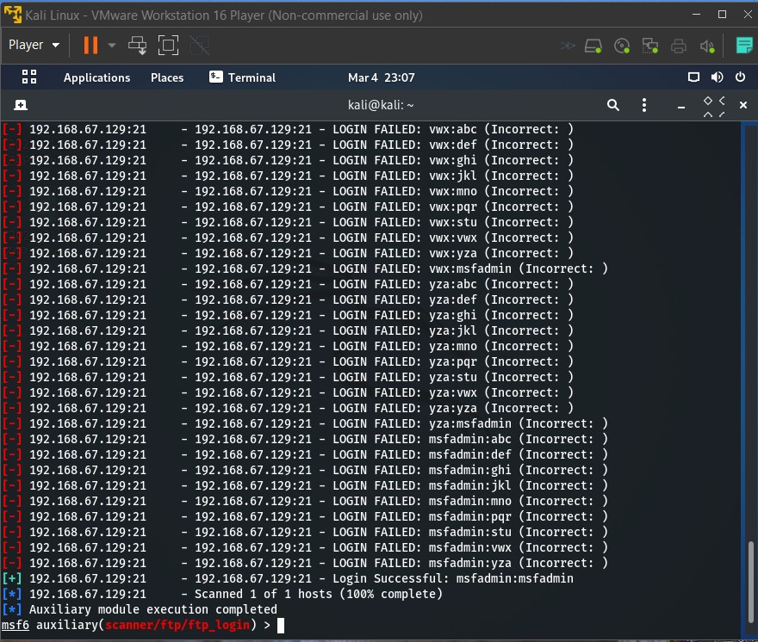

**Task 3 :-** NSE Scripts

Solution :-

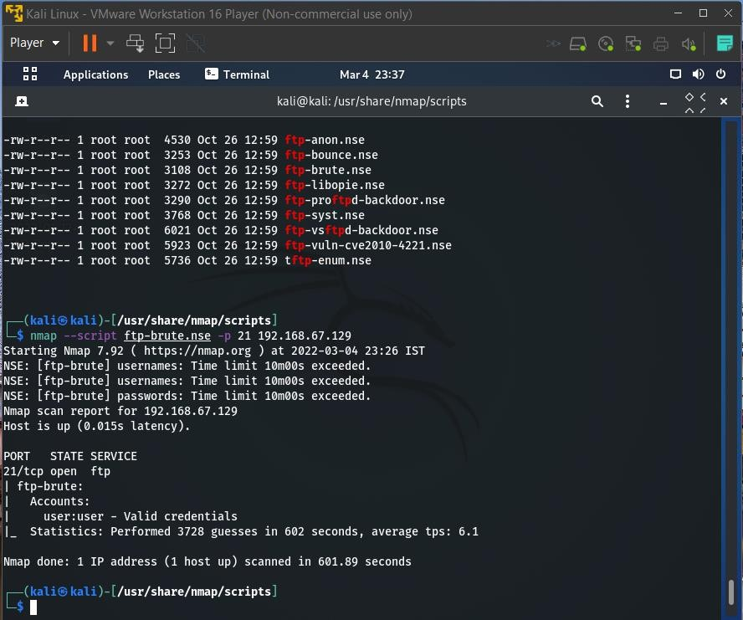

**Task 4 :-** John the ripper

Solution :-

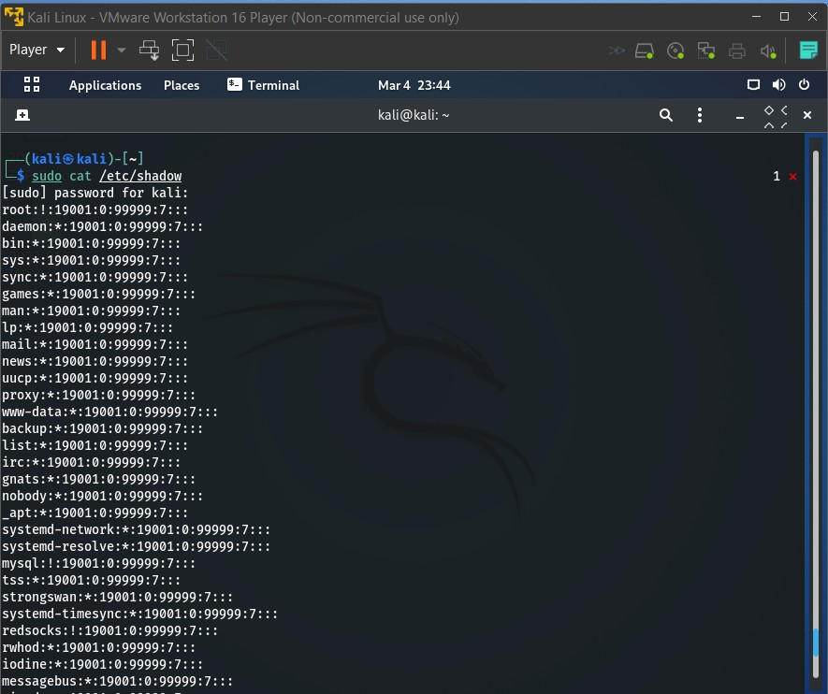

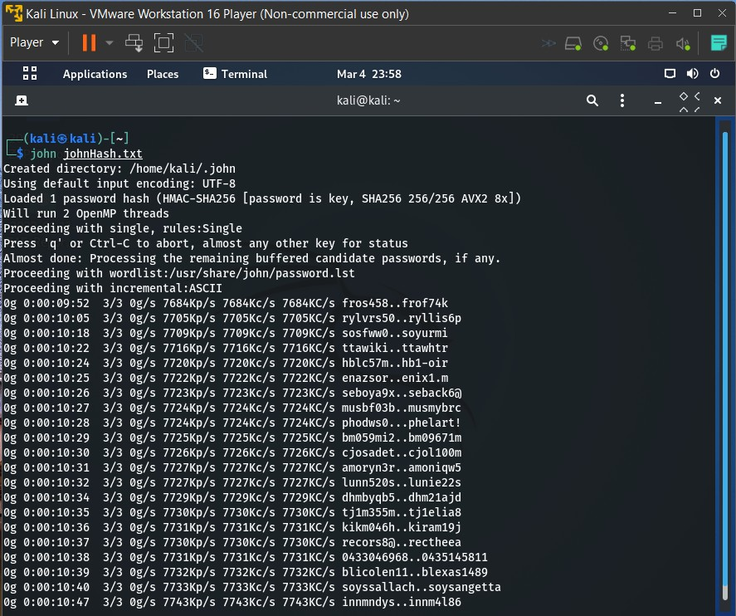

**Task 5 :-** Password generating using Crunch

Solution :-

